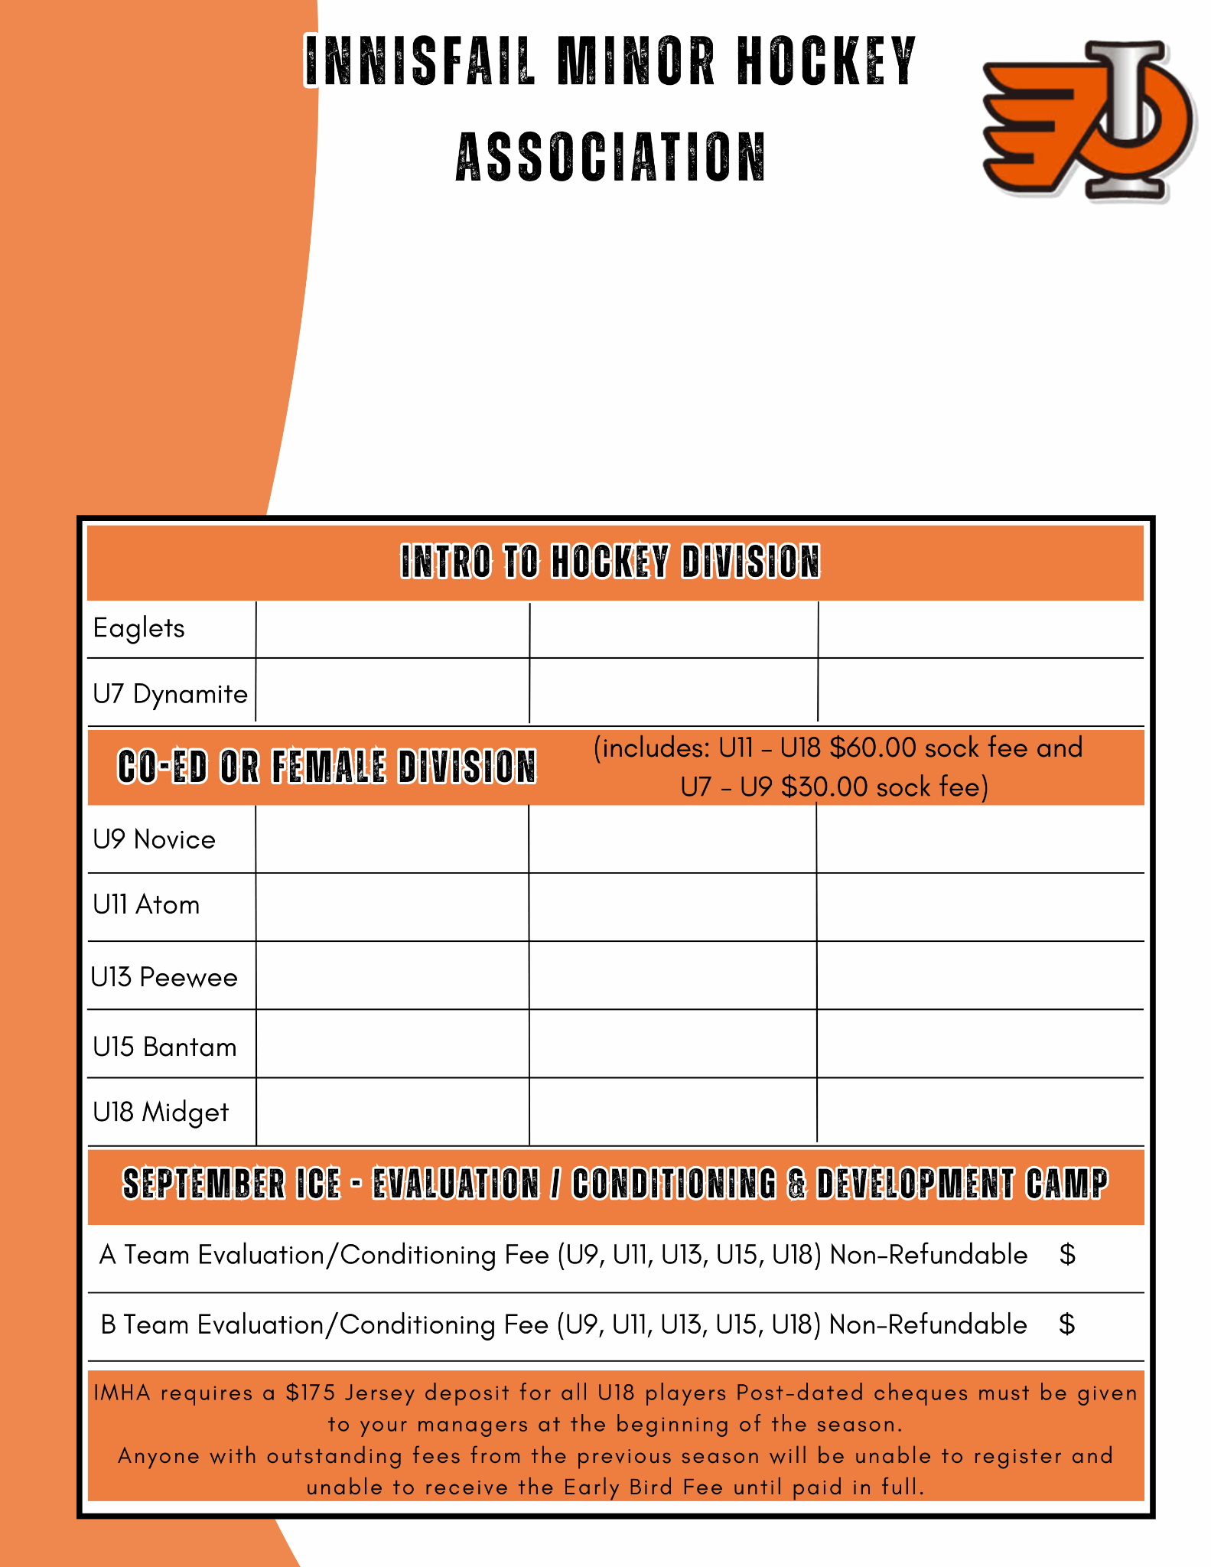

**NOTE: Early Bird Fees are in effect until July 31st, 2026**

ALL EARLY BIRD PAYMENTS MUST BE SET UP ONLINE & CHEQUES IN FULL OR
POST-DATED TURNED INTO THE IMHA OFFICE BY JULY 31st, 2026, OR WILL BE
SUBJECT TO PAY THE REGULAR FEES.

INSTALLMENT PAYMENT PLANS FOR JUNE - OCTOBER 31st, 2026 CAN BE SET
UP DURING REGISTRATION.

Born 2022 Early Bird $200 Regular $200

Born 2020-2021 Early Bird $575 Regular $575

Born 2018 - 2019 Early Bird $700 Regular $850

Born 2016 - 2017 Early Bird $925 Regular $1,075

Born 2014 - 2015 Early Bird $1,000 Regular $1,150

Born 2012 - 2013 Early Bird $1,050 Regular $1,200

Born 2009, 2010, 2011 Early Bird $1,100 Regular $1,250

150

75

